**Assignment # 1:**

**Topic :** Implementation of Apriori Algorithm using Python

**Submitted By :**

Abubaker Saleem (BSIT51F21S064)

M Abrar Ahmed (BSIT51F21S087)

**Submitted to :**

Dr. Hikmat Ullah Khan

**Dataset:**

Market Basket Optimisation

**Aim:**

The aim of this task is to perform Market Basket Analysis using the Apriori Algorithm. Market Basket Analysis is a data mining technique used to discover associations between items purchased together in transactions. By analyzing these associations, businesses can gain insights into customer purchasing behavior, optimize product placement, and design targeted marketing strategies.

**Data:**

* **Dataset Name**: Market Basket Analysis Dataset
* **Source:** This dataset is generated for the purpose of this task.
* **Number of Instances:** 30 transactions
* **Attributes:**
  + **Items:** A list of items purchased in each transaction.
    - **Numeric Features**: N/A
    - **Categorical Features:** Items
      * Sample Values: 'turkey', 'avocado', 'mineral water', 'milk', 'energy bar', 'whole wheat rice', 'green tea', 'low fat yogurt', 'whole wheat pasta', 'french fries', 'soup', 'light cream', 'shallot', 'frozen vegetables', 'spaghetti', 'eggs', 'pet food', 'cookies', 'burgers', 'cooking oil', 'champagne', 'salmon', 'shrimp', 'chocolate', 'chicken', 'honey', 'oil', 'fresh tuna', 'tomatoes', 'black tea', 'meatballs', 'red wine', 'pasta', 'pepper', 'rice', 'sparkling water', 'ham', 'body spray', 'pancakes', 'grated cheese', 'white wine', 'toothpaste', 'parmesan cheese', 'fresh bread', 'ground beef', 'energy bar', 'black tea', 'frozen smoothie', 'escalope'

**Code:**

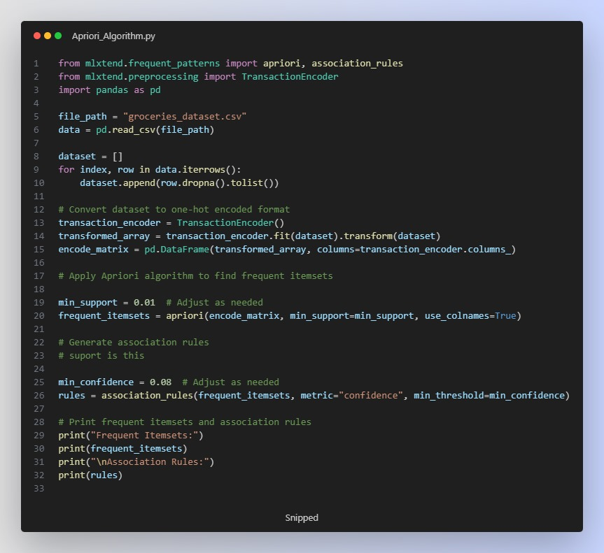

**Results:**

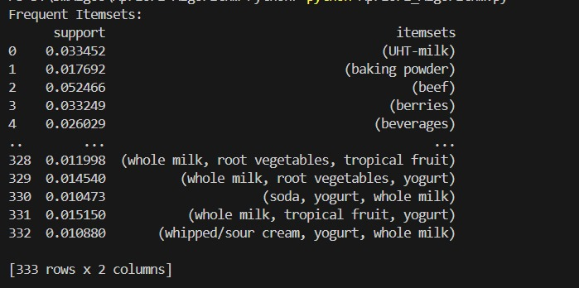

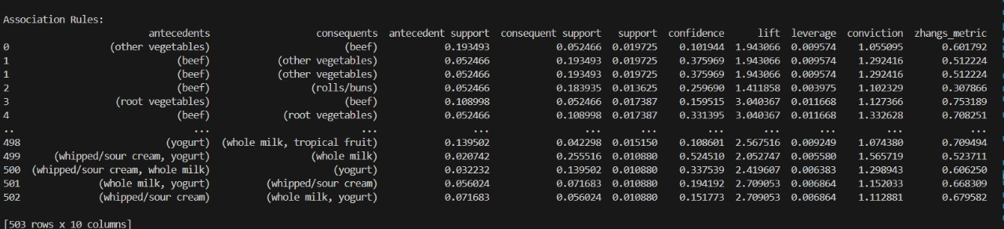

* With lower support thresholds, more frequent itemsets are discovered, leading to a larger number of association rules.
* Higher confidence thresholds result in fewer but more reliable association rules.
* The number of itemsets and rules varies depending on the combination of support and confidence values.

**Reference and Acknowledgement:**

**Data Source:** Kaggle

No external tutorials or references were used in this assignment